Title: | Window Lifter

History
Issue status  (Index) | Maturity/Date  (draft/invalid/valid)  (dd-mmm-yyyy) | Author  Department | Check/Release  Department | Description
1.0 | Draft  04-0ct-09 | Miguel Garcia | Miguel Garcia | Creation of the document
1.1 | Draft  20-Jul-15 | Francisco | Francisco | Check requirements and assumptions

Table of Contents
1 Purpose 4
2 Definitions and abbreviations 4
3 Realization constraints and targets 5
4 SW Conceptual design 5
5 SW Component internal breakdown 6
5.1 Function void dummy_500us(void) 7
5.2 Function void dummy_Init_endlessloop(void) 8
5.3 Function void dummy_Check_Button_Press(void) 8
5.4 Function void dummy_Check_Time_Press(void) 10
5.5 Function void dummy_Led_Response(void) 12

Purpose
Window lifter is the module responsible to control the window movement in a car. For this software design the window has to be emulated using a 10 LED bar. Also include a module of security called anti-pinch.
Anti pinch is a feature than prevents accidents between window and some human body parts like arms, hands, head, etc.

Definitions and abbreviations
Definitions
WL Window Lifter
PIT Periodic Interrupt Timer
GPIO General Purpose Input Output
CES Continental Engineering Services
References
N° | Document name | Reference
1  2  3 | Window lifter requirements  Traceability Matrix Template  Window lifter requirements client modifications

Realization constraints and targets

Window lifter has to be emulated using a 10 led bar of red color.
Each transition between each turning on/off LED shall be 400 msec.
The up movement will be represented by a LED blue color.
The down movement will be represented by a LED green color.
The module has to be able to detect fail button press.
For to consider as valid one button press the button has to be pressed at least 10 milliseconds.
The button combination has to be considered as invalid.
If the button up/down is pressed more of 500 milliseconds, the movement of window turn in manual mode.
If the button up/down is pressed less of 500 milliseconds the movement of window turn in automatically mode..
Anti-pinch button press has to follow the same characteristics than up and down buttons for valid press.
The signal anti-pinch just can be considered as valid when the movement is up.
If this signal is valid then the module has to stop the up movement and the down the window until the window get totally open. After that the module has to ignore during 5 seconds all button press.

SW Conceptual design

Use Cases Diagram
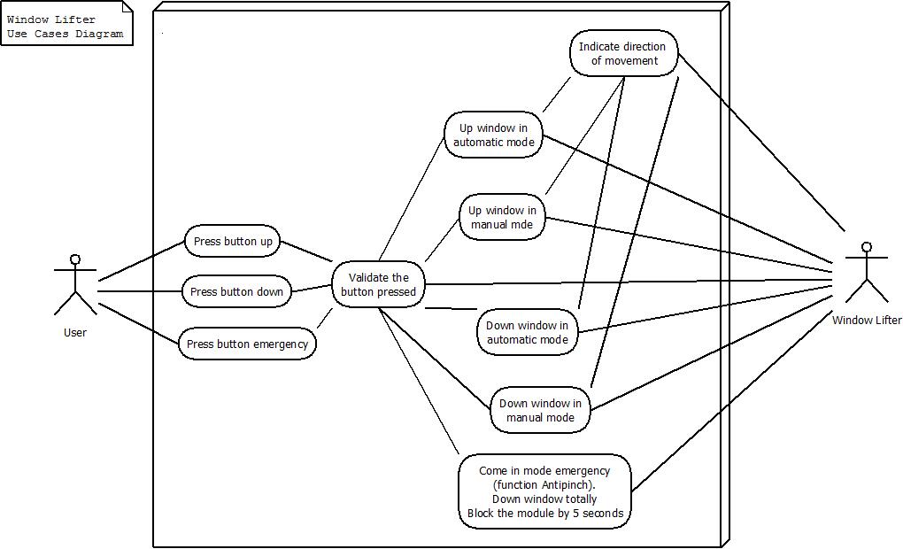

Component Diagram and Block Diagram
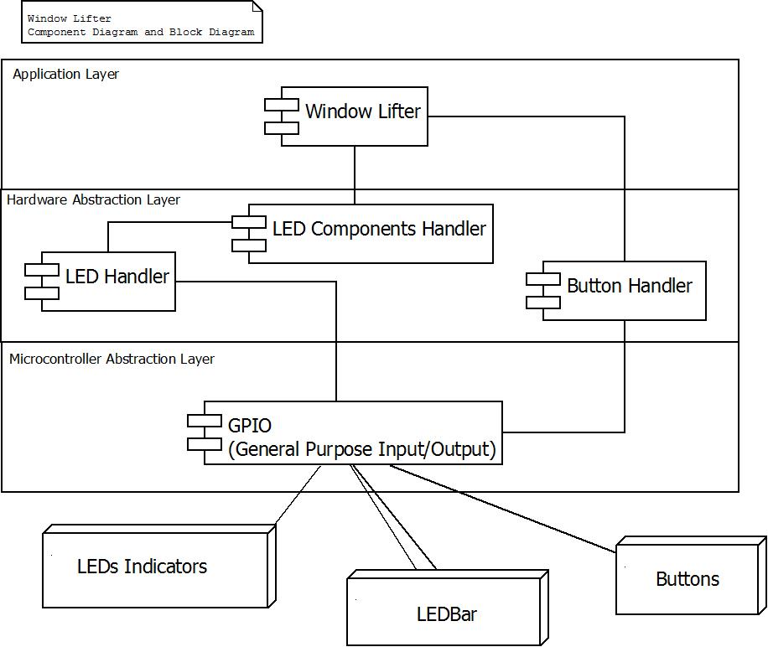

Class Diagram
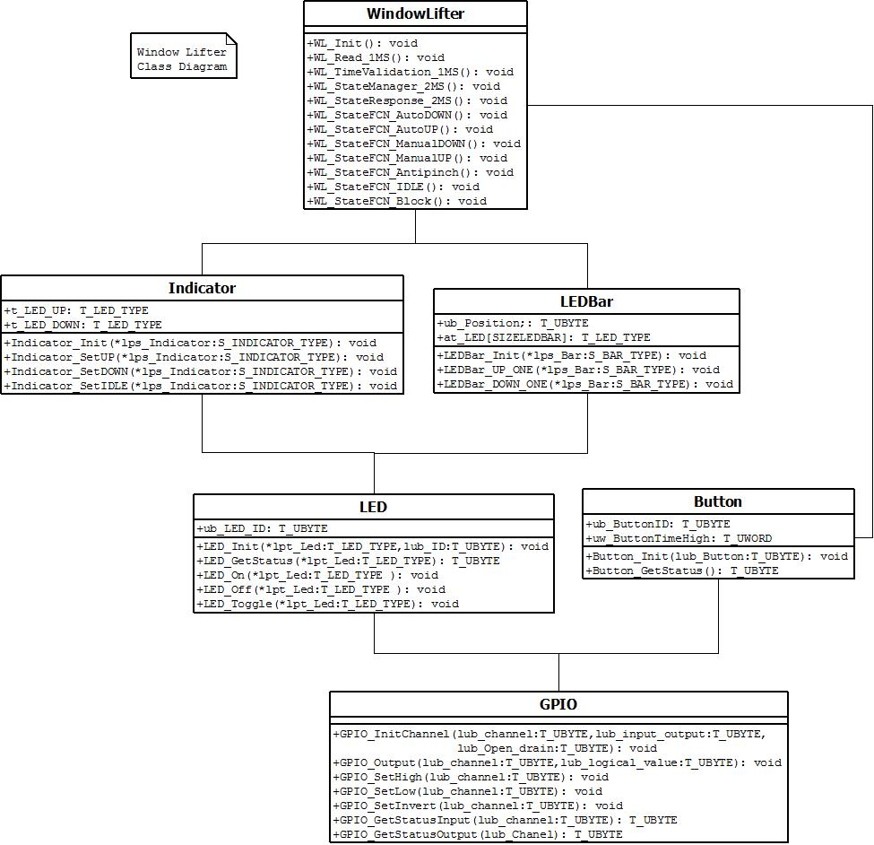

Activity Diagram
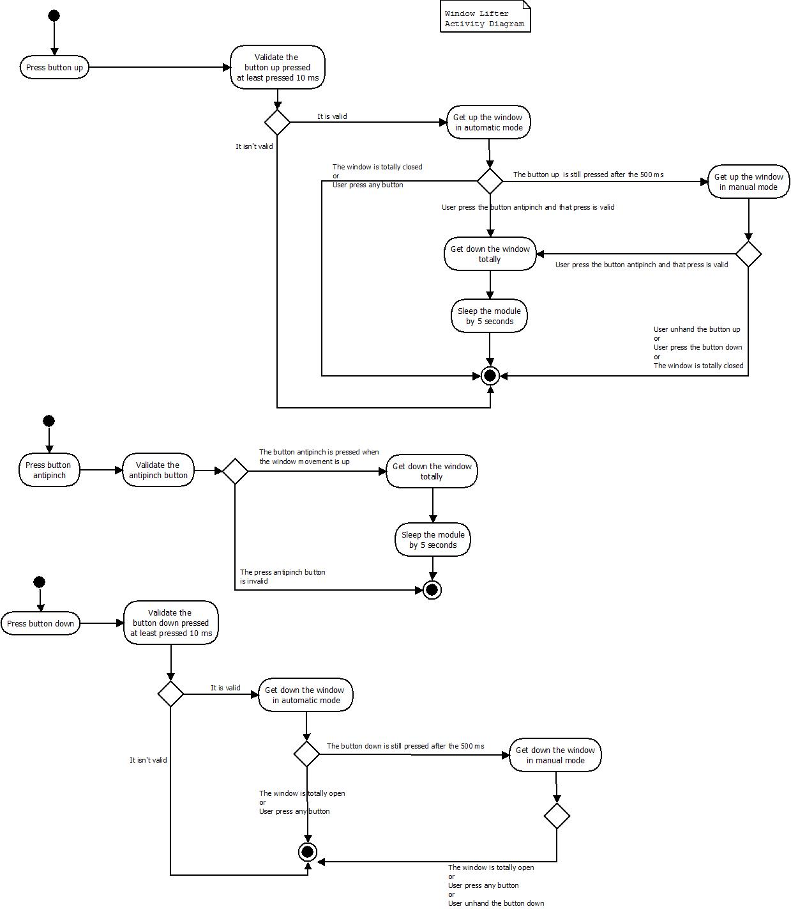

Sequence Diagram
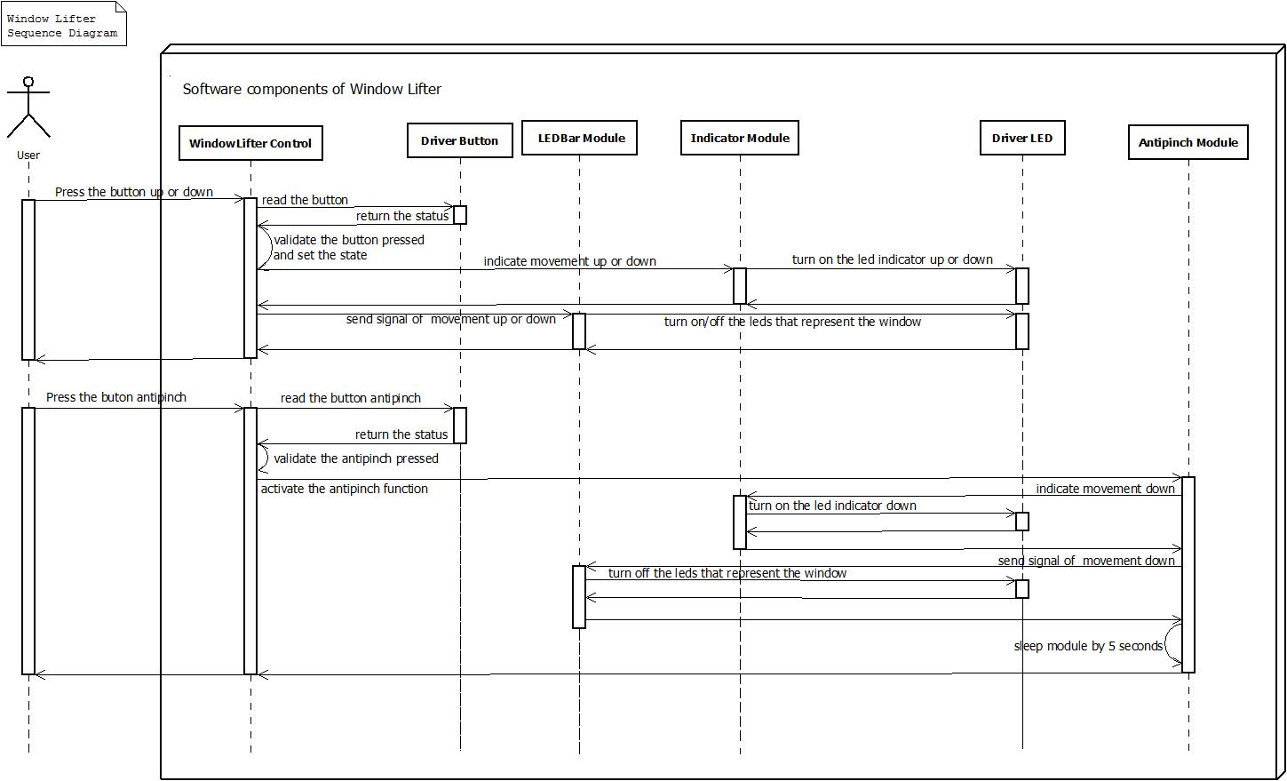

States Diagram
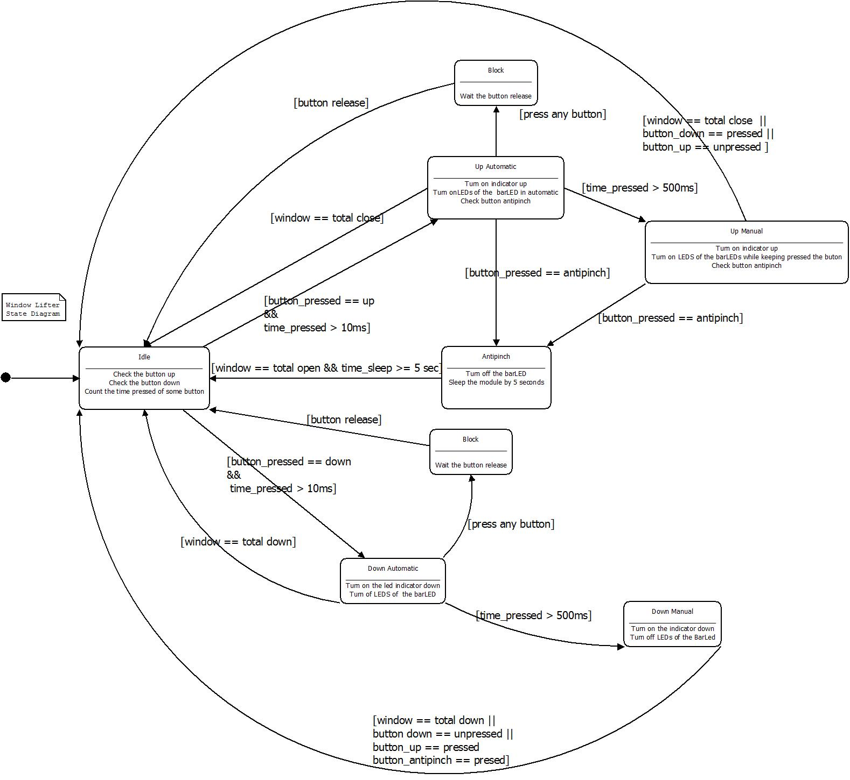

SW Component internal breakdown
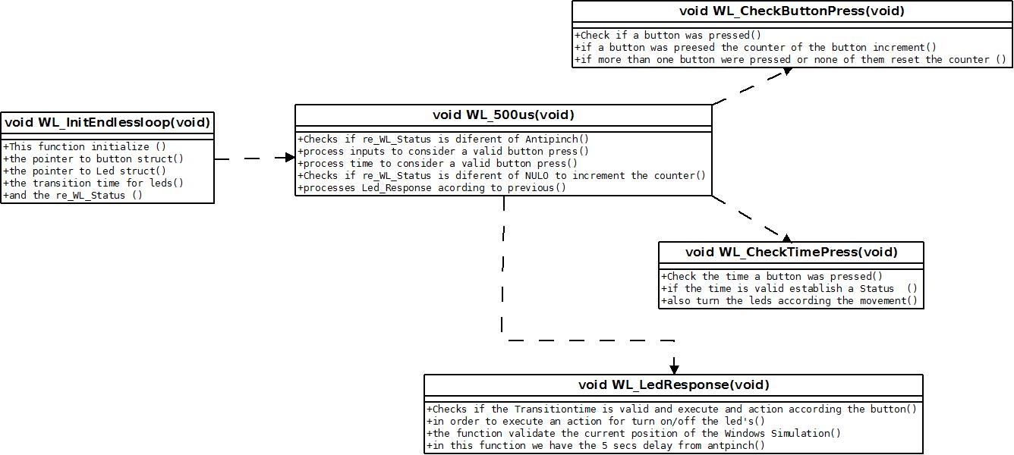
Function Description and Dynamic Behavior

Function void WL_500us(void)

Description | This function is executed every 500us, is the main function of the code, this function controls the flow of calls of all the others dummy functions
Parameter 1 | void
Return Value | void
Precondition | The PIT timer every 500us
Post condition
Error Conditions

Dynamic Behavior

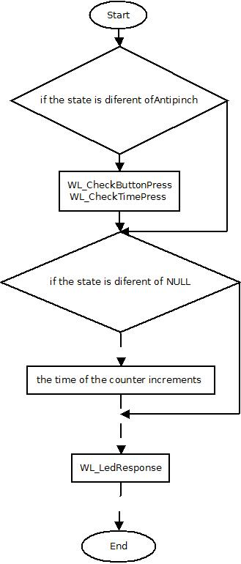

Function void WL_InitEndlessloop(void)

Description | This function initialize all the struct and typedef and use an endless loop to ensure that the microcontroller does not stop
Parameter 1 | void
Return Value | void
Precondition
Post condition
Error Conditions

Dynamic Behavior
This function Initialize rps_ButtonPtr, rps_LedPtr, ruw_TransitionTime and re_WL_Status.

Function void WL_CheckButtonPress(void)

Description | This function is responsible for monitoring inputs and validates whether a button is pressed if multiple buttons are pressed or not pressed any, and when it is valid increment the count of the button.
Parameter 1 | Void
Return Value | Void
Precondition | re_WL_Status must be different of PINCH
Post condition | Positions the pointer rps_ButtonPtr in one of the elements of the table
Error Conditions

Dynamic Behavior

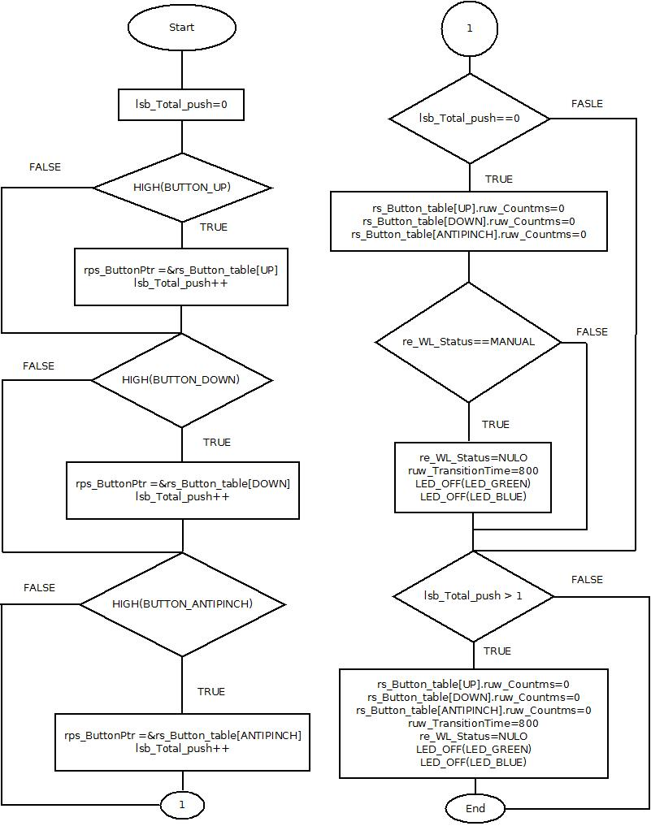

Function void dummy_Check_Time_Press(void)

Description | This function is responsible for monitoring the time that a button has been pressed and select whether the state is AUTO, MANUAL ANTIPINCH or NULO,
Parameter 1 | Void
Return Value | Void
Precondition | re_WL_Status must be different of PINCH
Post condition | Establish the state of the variable re_WL_Status
Error Conditions

Dynamic Behavior

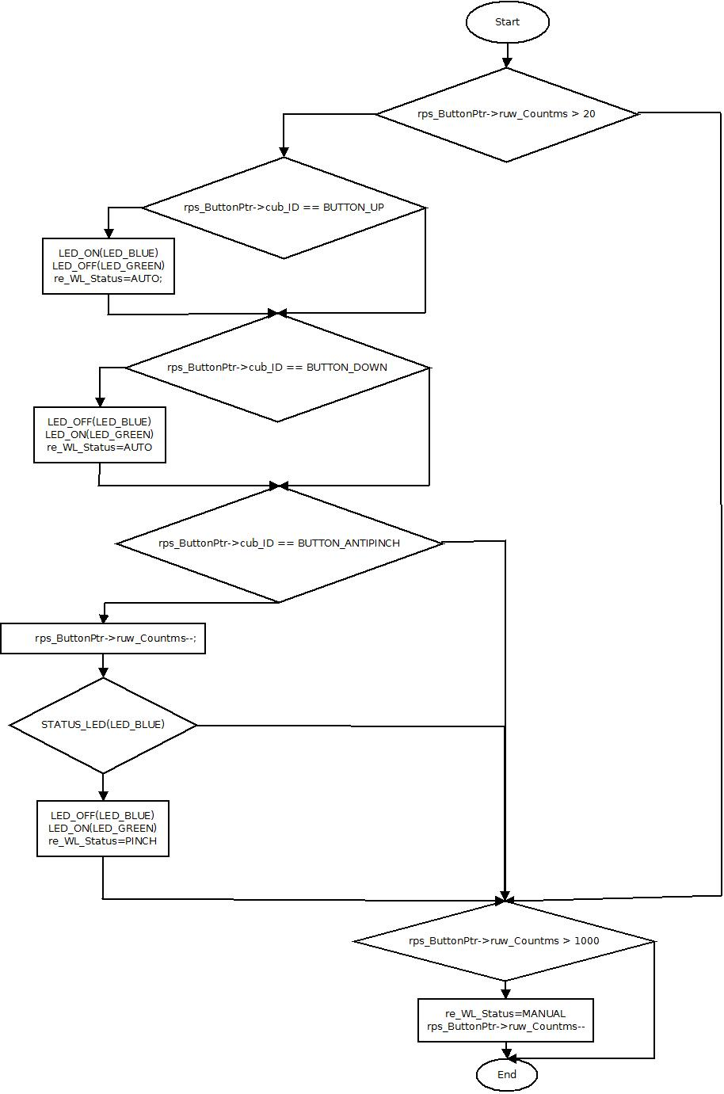

Function void dummy_Led_Response(void)

Description | This function is responsible for the secure and correct time simulation of the WL according to the Button pressed
Parameter 1 | Void
Return Value | Void
Precondition
Post condition
Error Conditions

Dynamic Behavior

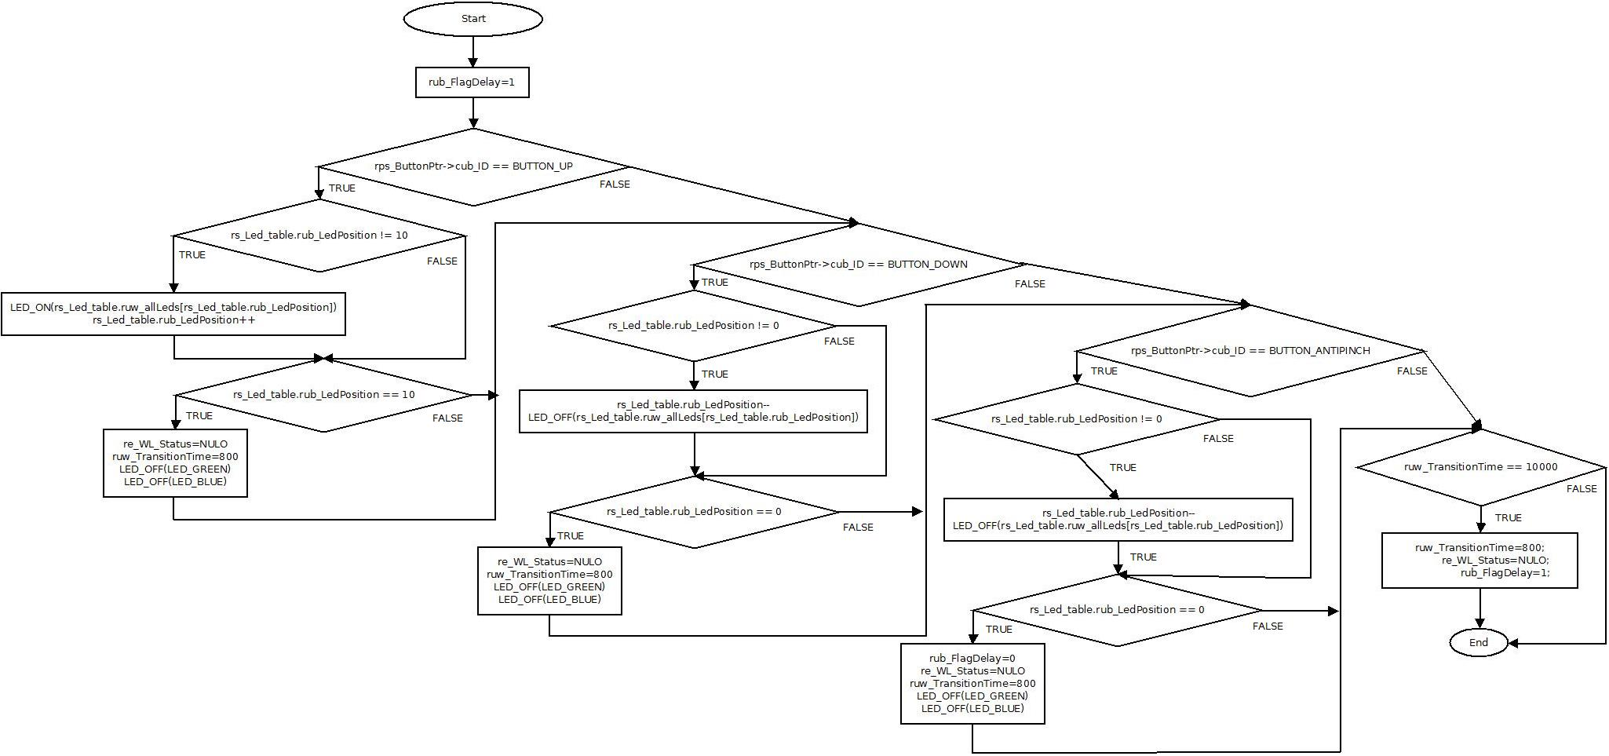

Function void dummy_Led_Response(void)

Description | This function is responsible for the secure and correct time simulation of the WL according to the Button pressed
Parameter 1 | Void
Return Value | Void
Precondition
Post condition
Error Conditions

Dynamic Behavior

